**3B Dictionary Attack**

Files:

**Passlist.txt**

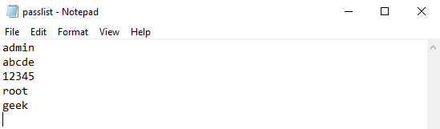

**Md5list.txt**

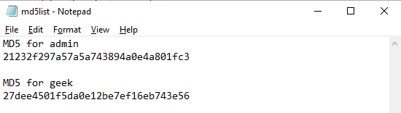

**Code:**

**Dictattack.py**

import hashlib

flag=0

p_hash=input("Enter MD5 hash")

dictionary=input("Enter dictionary Filename:")

try:

password_file=open(dictionary,"r")

except:

print("No file found")

quit()

for word in password_file:

enc_word=word.encode('utf-8')

digest =hashlib.md5(enc_word.strip()).hexdigest()

if(digest==p_hash):

print("password has been found")

print("password is :" +word)

flag=1

break

if(flag==0):

print("No password found")

**Output:**

